Task 2 :- Analyse a Phishing Email Sample

- Sample Phishing Email

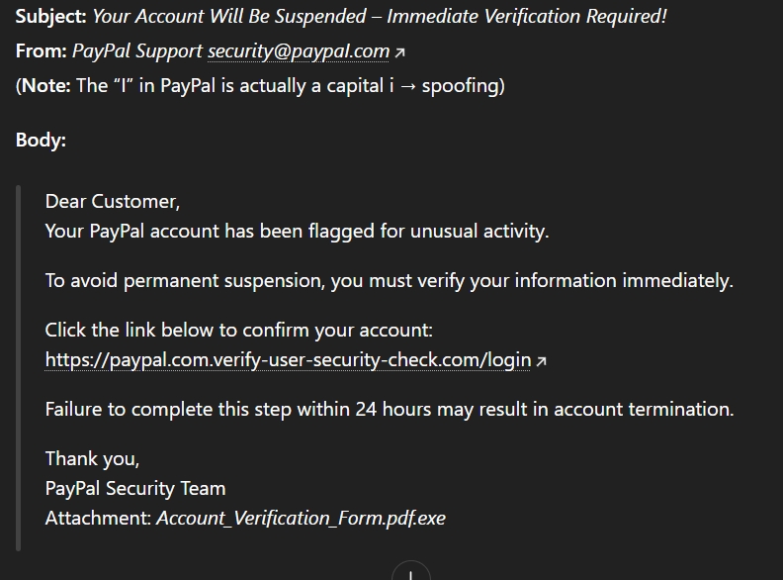

1. Sender Email Verification
The sender address looks like it belongs to PayPal, but the domain is slightly altered.
Instead of paypal.com, it uses paypaI.com, where the letter “I” is replaced with a capital "i".
This is a common trick used in phishing emails to fool users.
Conclusion: Sender address is fake

2. Email Header Review
A header analysis (using tools like MXToolbox or Google Admin Toolbox) would show:
SPF: Failed → Server not authorised to send this email
DKIM: Failed → Signature does not match real domain
DMARC: Failed → The domain denies this email

These failures clearly show the email is not coming from the legitimate PayPal servers.
Conclusion: Email is spoofed.

3)URL Inspection
Displayed link appears to contain “PayPal”, but the main domain is(secure-login-info-check.com)Everything before this (paypal.com.) is only a subdomain used to mislead users.
Conclusion: The link leads to a fake login page designed to steal credentials.

4. Emotional Manipulation
The email claims the account will be restricted within 24 hours, which creates fear and pressure.
Cybercriminals often push users to act quickly so they don’t have time to think.
Conclusion: The message uses urgency as a social engineering tactic.

5. Suspicious Attachment
Attachment name: Account_Update_Form.pdf.exe
The file pretends to be a PDF but is actually an executable (.exe), which can install malware.
Conclusion: Attachment is dangerous and likely malicious.

6. Language and Formatting IssuesGeneric greeting (“Hello User”)
- Slightly unnatural sentence flow
- Not the usual style of official PayPal messages
- Legitimate companies usually address customers by name and maintain professional formatting.
Conclusion: Email wording further suggests it is fraudulent.

7. Phishing Indicators Summary
Indicator | Evidence
Fake sender address | Slight spelling change in PayPal domain
Failing authentication | SPF/DKIM/DMARC all fail
Fake URL | Real domain is different from what is shown
Urgency | Threat of account lockout
Dangerous attachment | .exe file hidden behind .pdf
Generic greeting | Not personalized
Formatting issues | Unprofessional writing
Overall Conclusion:
The email is clearly a phishing attempt designed to steal PayPal login details and possibly install malware on the victim’s device.

Interview Answers

1. What is phishing?
Phishing is a method where attackers disguise themselves as trusted organizations to trick people into giving sensitive data like passwords, bank details, or OTPs.

2. How to identify a phishing email?
- Strange or misspelled sender address
- Unknown or mismatched URLs
- Urgent or threatening statements
- Unusual attachments
- Grammar mistakes
- Requests for personal information

3. What is email spoofing?
Email spoofing happens when attackers fake the “From” email address so it looks like it came from a legitimate organization.

4. Why are phishing emails dangerous?
They can steal login details, financial information, or spread malware, which may lead to identity theft or financial loss.

5. How can you verify the sender’s authenticity?
- Check the domain name properly
- Inspect email headers
- Look for SPF/DKIM/DMARC results
- Hover over links
- Contact the organization through official websites

6. What tools can analyze email headers?
- MXToolboxGoogle
- Admin Toolbox
- Message Header Analyzer
- Postmark Header Parser

What actions should be taken when you spot a phishing email?
- Do not click any link or attachment
- Report it to your IT/security team
- Block the sender
- Delete the email immediately
- Scan your system if you interacted with it accidentally

8. How do attackers use social engineering in phishing?
Attackers exploit emotions like fear, curiosity, and urgency to trick users into clicking links or giving information.

